Name: __________________________________________________________ Day ________ Period ________

Community Service Final Project

Step 1: FORMATTING: Changing Font Color, Style & Size.

Step 2: IMAGES: Add 1 images on slides 2-3 & 4 relating to titles.
**Use a GOOGLE IMAGE SEARCH. Copy/paste the images to your slide.**

Step 3: CUSTOMIZE the Slide Show:

A: Slide Transition: [Transitions Tab]
- You MUST remove the check in the “on mouse click” box.
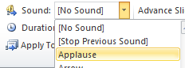
- Make transition choices for all 4 slides.
- Click your last slide and select the APPLAUSE Sound Clip.

B: Custom Animation: [Animations Tab]
- Select each object on the slide, pick an animation effect.
- Preview how each object on the slide appears & moves.
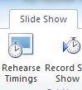
C: Setting & Rehearsing Timings [Slide Show Tab]
- Click the Slide Show Tab, click rehearse timing.
- Click when you are ready to advance each slide to the next.

Step 4: SAVING:
0Saving the file – click File, click Save As, select your ID# and name the file:
Community Service Final Project_ YOUR NAME

