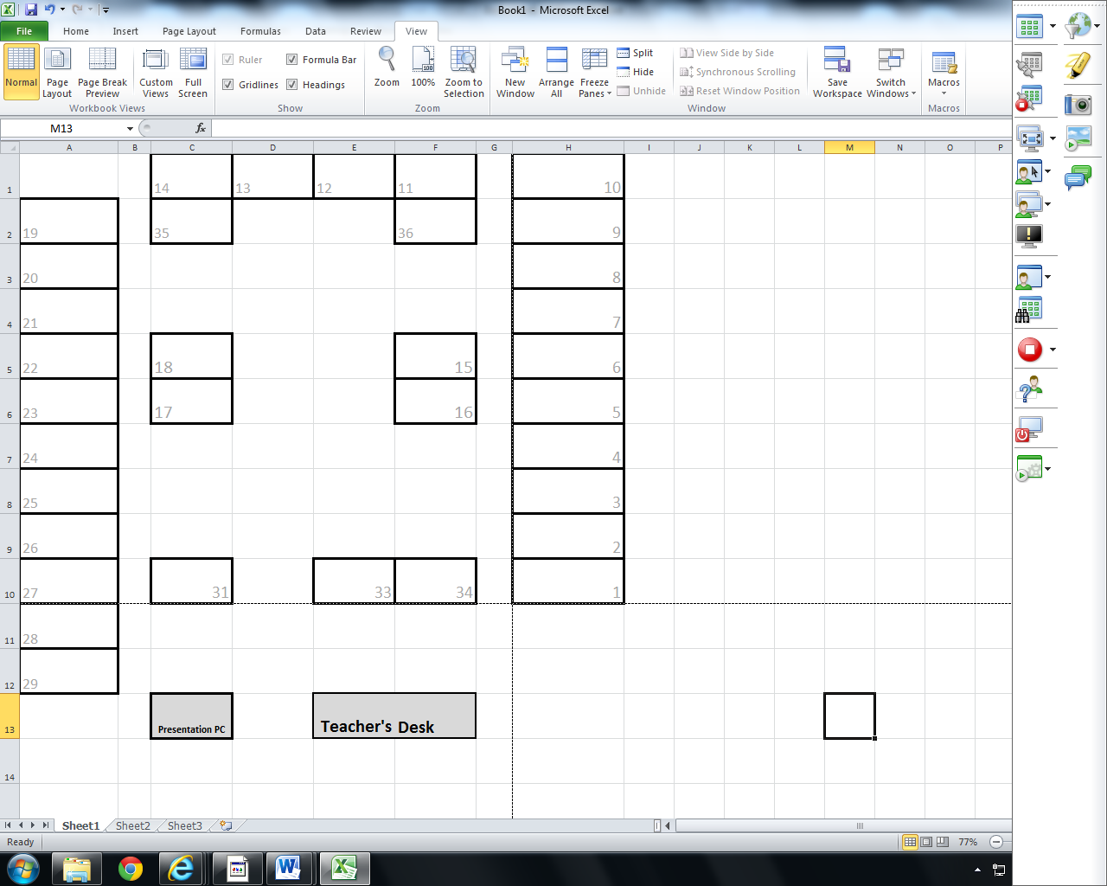

Day ______ Period _____ GR ____

Time: _______________________