Creating a Shortcut to Your Network Drive on your Desktop:
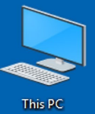
- Locate the THIS PC icon on your Desktop and double click to open.
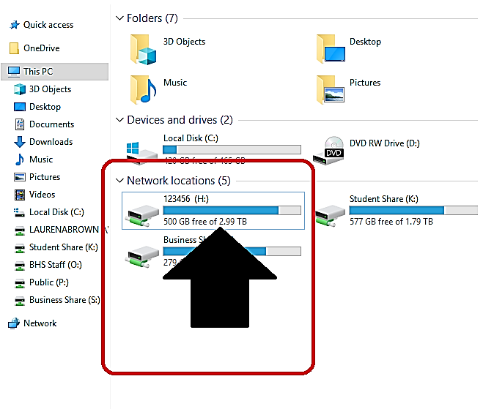

- In the This PC Window locate your ID Number in the Network Locations section of this window.

- Click and Drag that Icon outside the window and Drop
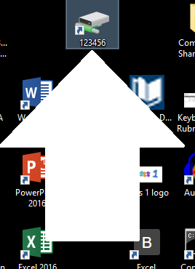
the icon on your desktop.
3
2

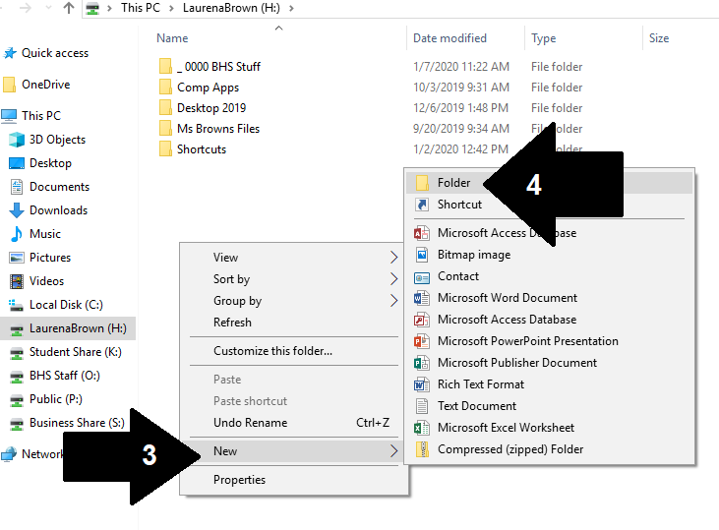
Creating a Class Folder on your Network Drive:

- Double click to Open your Network Drive.
- Right Click to access a menu.
- Click New
- Click Folder
- A folder will appear, and you will name the Folder COMP APPS.

Creating an Assignment Folders in your Class Folder:

- Double click to Open your COMP APPS Class folder.
- Right Click to access a menu.
- Click New.
- Click Folder.
- A folder will appear, and you will name the Folder WORD (DO NOT OPEN THIS FOLDER).
- Right Click again to access a menu, click New.
- A folder will appear, and you will name the Folder EXCEL (DO NOT OPEN THIS FOLDER).
- Right Click again to access a menu, click New.
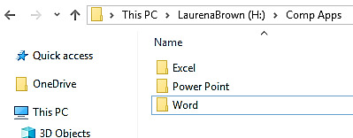
- A folder will appear, and you will name the Folder POWER POINT (DO NOT OPEN THIS FOLDER).
See picture to the right for an example.

Name: ______________________________________________
Day & Period: __________________________________
Date: _________________________________________

