SkillsUSA Career Essentials

Instructions for New Users to Access Accounts after Auto Uploads
Brockton High School, MA
- Go to https://mycareeressentials.org

- Click the blue Login button in the upper right of the page
- Enter your Username (email address) and Temporary Password - 123456
- System will prompt student to re-set password (student should set password to something they can easily remember).
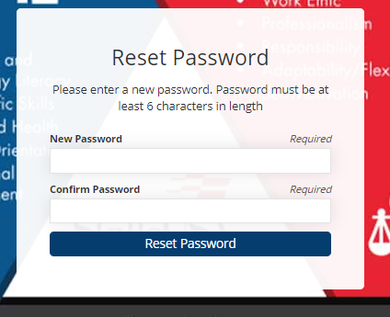
- Once student has re-set password, they will receive the following screen and should click on Login. This will take the student back to the blue login function.

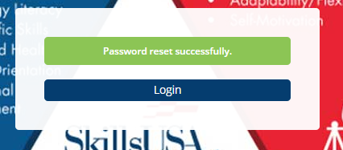
- Student will login to the LMS using their email address and newly established password.
- On your Dashboard locate the tile titled, Have an enrollment key
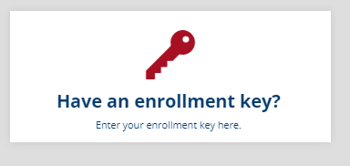
- Enter the enrollment key provided for specific class/course in the appropriate field and click Enroll
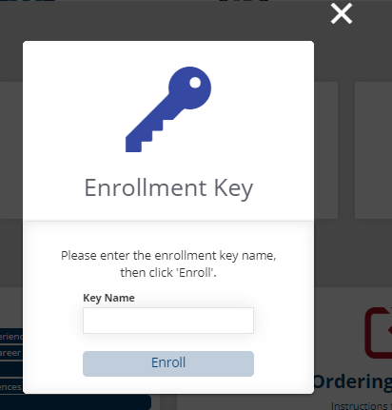
- Once the enrollment key is entered, navigate to the My Courses tile on your dashboard to access the new item.
